# **1. Sprint Backlog**

|  |  |  |  |  |  |  |
| --- | --- | --- | --- | --- | --- | --- |
| **ID** | **User Story** | **Description** | **Status** | **Story Points** | **Priority** | **Risk** |

# **2. Sprint Deliverables**

|  |  |  |  |  |  |
| --- | --- | --- | --- | --- | --- |
| Deliverable | Description | Owner | Associated User Stories | Status | Notes |

# **3. Burndown Chart**

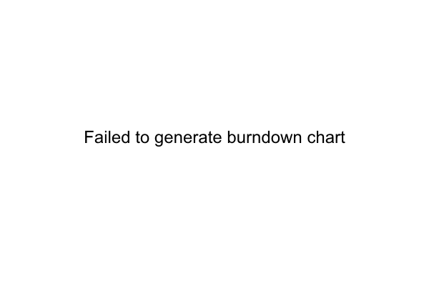

# **4. Impediment Log**

|  |  |  |  |  |  |  |
| --- | --- | --- | --- | --- | --- | --- |
| Summary | Description | Reported by | Responsible Person | Status | Reported Date | Close Date |

# **5. Sprint Retrospective**

## **5.1. Start Items**

|  |  |
| --- | --- |
| Item | Vote |

## **5.2. Stop Items**

|  |  |
| --- | --- |
| Item | Vote |

## **5.3. Continue Items**

|  |  |
| --- | --- |
| Item | Vote |